Essbase Schedule checkup

Overview:
- Monday to Friday will be considered as Business days.
- At 8:30 PM EST - Confirm the Nightly schedule completion in qessbs01 and qessbs02 from the mails received as part of the schedule.
- IT Boston team will notify the schedule changes and if we find any discrepancies, we will reach them.
On Call Schedule:
On-Call Schedule .xlsx (sharepoint.com)
Schedule sheet:
EssbaseSchedule.xlsx (sharepoint.com)
Sample schedule day calculation:
- Month start business day will be considered as DAY1.
- Month end business day will be considered as DAY-1.
Date | Day | Schedule Name
1 | Tuesday | DAY1
2 | Wednesday | DAY2
3 | Thursday | DAY3
4 | Friday | DAY4
5 | Saturday
6 | Sunday
7 | Monday | DAY5
8 | Tuesday(US Holiday)
9 | Wednesday | DAY6
10 | Thursday | DAY7
11 | Friday | DAY8
12 | Saturday
13 | Sunday
14 | Monday | DAY9
15 | Tuesday | DAY10
16 | Wednesday | DAY11
17 | Thursday | DAY12
18 | Friday(US Holiday)
19 | Saturday
20 | Sunday
21 | Monday | DAY13
22 | Tuesday | DAY14
23 | Wednesday | DAY15
24 | Thursday | DAY16
25 | Friday | DAY-5
26 | Saturday
27 | Sunday
28 | Monday | DAY-4
29 | Tuesday | DAY-3
30 | Wednesday | DAY-2
31 | Thursday | DAY-1

- Go to Essbase notification mailbox <Essbase_Notification@LibertyMutual.com>
- Filter by subjects and collapse all groups
- Search for Nightly Schedule lxpip-qessbs01 and Nightly Schedule lxpip-qessbs02(Key word Nig)
- Compare the jobs ran with the schedule in the schedule sheet.
- The jobs ran in servers 01 and 02 should match the jobs in the schedule.
- In case of any issues, we need to inform the on-call person as soon as the schedule is verified and before 9:30 PM EST thru call & email.
- Team monitors the Essbase notifications mailbox to see no failures has been reported thru emails and completion subjected to the jobs scheduled(Email subjects as in attached below) has been received. In case of any failure notification/long running monitored, team would call the on-call of IT BOSTON team per below POC schedule:

- Change the 4:30 AM call to the on-call support person to 6:00 AM depending on the following criteria
  - On ALL DAYS it is not necessary to contact GFT on-call until 6:00AM if the majority of jobs have completed and a couple are in process. If there are jobs that haven’t completed by 5:30AM, we ask that you perform two tasks before calling GFT on-call support.
    - Submit a Remedy request to run fnp_fnepm_EssValCalcPIP11 or fnp_fnepm_EssValCalcPIP12 depending on the server that hasn’t completed all jobs. Wait 10 minutes and check the Essbase Notifications mailbox for the successful job completion emails. The result will be the same as done on each Sunday night restart of Essbase services. Successful completed emails indicates Essbase is working. If a “completed” email does not arrive into Essbase Notifications, please call GFT on-call support.
    - Login to Essbase using Smartview. Navigate to the EssVal application and verify that you can connect and obtain the applications dimensions. Successful connection and retrieval indicates Essbase is working. If you cannot connect to the EssVal application please call GFT on-call support.

NOTE - On Days 1 and 2, the mainframe post is held until 2AM, therefore some Essbase jobs will not complete until 5:30AM. If jobs have not completed by 5:30 AM, please follow the above procedures in #1.

Sample Schedule Sheet:

Essbase Server checkup
- Go to Essbase notification mailbox <Essbase_Notification@LibertyMutual.com>
- Filter by subjects.
- Collapse all groups.
- Search for key word ESS
- Search for mail subject - Essbase production server and expand it.
- Find the mail for the server status
- Find out weather both servers are running.
- Mon–Fri At 10:00 PM /12:00 AM/2:00/4:00AM AM EST-every 2 hours once – Confirm the status (running or Stopped) of the Servers through emails.
- If any server status is not running, immediately inform IT BOSTON through On-call and drop an email
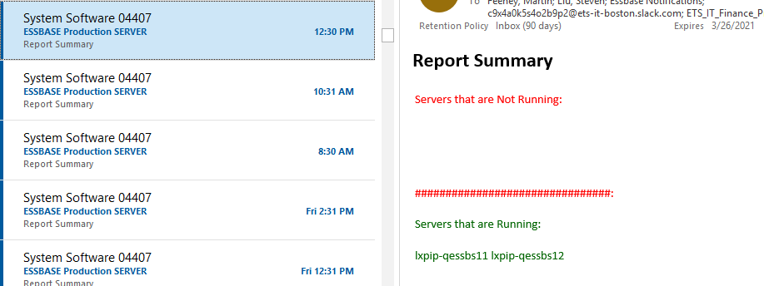

Essbase Schedule completion
Overview:
- Monday to Friday will be considered as Business days.
- Daily schedule jobs should complete before 6 AM EST(Jobs will get completed around 3 AM on normal days). Usually during start of a month, job runs longer than usual. Status on the job schedule completion must be send to IT BOSTON team before 6 am.
Steps to follow:
- Go to Essbase notification mailbox
- Filter by subjects and collapse all groups
- Search for Nightly Schedule lxpip-qessbs01 and Nightly Schedule lxpip-qessbs02(Key word Nig)
- Copy all the scripts and group it together in a new mails.
- The jobs which ran in the scripts can be verified by comparing it with the mails received.
- The document contains the respective job names and the corresponding mails.
- To verify mails received
  - Go to essbase notification mailbox
  - Filter by subjects and collapse all groups
  - Compare the jobs with its corresponding mails received
  - If the mail is available, make the font color of the job as green
  - If the mail is not received make the font color of the job as red
- After verifying for all jobs send the mail to I/S_Corporate_BoSunday ston and to the respective oncall person.
- The details of the oncall person can be found in the below link.
- Oncall : On-Call Schedule .xlsx (sharepoint.com)
- Note: There may be special processing on Saturday/which would be demanded by IT Boston team and the same has to be monitored with the above steps.

Incident Tracking and ServiceNow Ticket Management

ServiceNow Ticket Creation:
Whenever an issue is identified that requires escalation to the on-call support person, a ServiceNow incident ticket must be created for tracking purposes.
Examples of issues requiring ticket creation include, but are not limited to:
- Schedule mismatch between planned and executed jobs.
- Essbase server failure or server status reported as stopped.
- Job failures or abnormal job termination.
- Long-running jobs requiring investigation.
- Missing schedule completion notifications.
- Any issue that requires engagement of the on-call support team.

Ticket Assignment and Notifications:

- While creating the ServiceNow ticket Add " ESSBASE CRIBS APP SUPPORT" as the notification/distribution list (DL).
- Assign the ticket to the support team member handling the issue.
- Include complete issue details, impacted server(s), job name(s), error messages, and actions taken.
- Mention the ServiceNow incident number in all email communications sent to the on-call person and IT Boston team.

Ticket Resolution:

- Continue updating the ServiceNow ticket with troubleshooting activities, communications, and status updates.
- Once the issue has been resolved and validated, update the ticket with the resolution details.
- Resolve/close the ServiceNow ticket after confirmation that services, schedules, or jobs are functioning normally.
- Ensure all stakeholders are informed of the resolution through the ticket and/or email communication.

